**Prepared By:**

**Afsana Mitu**

**Roll 18**

**Table Of Contents**

|  |  |  |  |  |  |  |
| --- | --- | --- | --- | --- | --- | --- |
|  | **Serial**  **Number** | | **Topic** | **Page No** | | |
| **\*** | | Executive summary | **07** | | |
|  | | **Chapter 1 Introduction** |  | | |
| 1.1 | | Origin of the report | **08** | | |
| 1.2 | | Objective of the report | **08** | | |
| 1.3 | | Methodology of the report | **08** | | |
| 1.4 | | Sources of data | **08** | | |
| 1.5 | | Limitation of the study | **08-09** | | |
|  | | **Chapter 2**  **Working capital management** |  | | |
| 2.1 | | Introduction | **10** | | |
| 2.2 | | Elements of working capital | **10-11** | | |
| 2.3 | | Importance of working capital | **11** | | |
|  | | **Chapter 3 Company overview** |  | | |
| 3.1 | | Beximco Pharmaceuticals Limited | **12** | | |
| 3.2 | | Square Pharmaceuticals Limited | **12-13** | | |
| 3.3 | | Mission & Vision of Beximco Pharmaceuticals Limited | **13** | | |
| 3.4 | | Mission & Vision of Square Pharmaceuticals Limited | **13** | | |
| 3.5 | | Core value of Beximco Pharmaceuticals Limited | **13** | | |
| 3.6 | | Core value of Square Pharmaceuticals Limited | **13** | | |
|  | |  |  | | |
|  |  |  | **Chapter 4**  **Financial performance analysis of**  **Beximco &**  **Square Pharmaceutical Ltd.”** | |  | |
| (A) |  | **Activity ratios :** | | **14** | |
| 1 |  | Inventory turnover ratio | | **14-16** | |
| 2 |  | Inventory conversion period | | **17-18** | |
| 3 |  | Receivable turnover ratio | | **19-20** | |
| 4 |  | Average collection period | | **21-22** | |
| 5 |  | Payable turnover | | **23-25** | |
| 6 |  | Average number of day’s payable outstanding | | **26-27** | |
| (B ) |  | **Liquidity ratios:** | | **28** | |
| 1 |  | Operating cycle | | **28-30** | |
| 2 |  | Current ratio | | **31-33** | |
| 3 |  | Quick ratio | | **34-36** | |
| 4 |  | Cash ratio | | **37-39** | |
| 5 |  | Cash conversion cycle | | **40-42** | |
| 6 |  | Comprehensive liquidity index | | **43-45** | |
| 7 |  | Net liquid balance | | **46-48** | |
|  | **(C )** | **Profitability ratios** | | | **49** |  |
| **1** | Gross margin ratio | | | **49-51** |
| **2** | Net profit margin ratio | | | **52-54** |
|  | **Chapter 5**  **Recommendation and conclusion** | | |  |
| **5.1** | Recommendation | | | **55** |
| **5.2** | Conclusion | | | **55** |
|  | Reference | | | **56** |

# Executive Summary

Managing a firm’s current assets and liabilities (working capital management) is highly relevant to the success of that firm. While the short-term liquidity effects of working capital management are straightforward to derive, it is an empirical question how it affects firm profitability. This short survey paper consolidates the empirical literature on the association between working capital management and firm profitability. This state of the art analysis provides evidence of positive effects of accounts receivable management and inventory management on profitability. However, results for the effects of accounts payable management on profitability are driven by reverse causality. Finally, this paper highlights critical aspects of prior research and points to avenues for future research.

**1.1 Origin Of The Report:**

The report is originated to make a study on Working Capital Management and its Impact on Profitability, A Case Study of Cement Industry as a part of the fulfillment of BBA Program of Barisal University. As a part of BBA Program this report is assigned to me by my honorable course teacher Tandra Mondal.

**1.2 Objective Of The Report:**

The purpose of this report is:

* To know about Working Capital Management.
* To Know How the company manage it.
* To know Impact of working capital Management on profitability.
* To examine the profitability position of the selected cements industries.
* To examine the working capital management position of selected Cements industries.
* To assess the relationship between working capital management and profitability.
* To assess the impact of working capital management on profitability

**1.3 Methodology Of The Report:**

Data regarding the organization profile collected in the following ways:

* Carefully observation of various side of Working Capital Management.
* Discussion with group members.
* Online information. . • Secondary Data.

**Secondary Data:** Most of the data collected from internet. Some data collected by observing report and presentation relates with this topics.

**1.4 Sources of Data:**

Secondary Data were used to complete this study. Sources of the secondary data were.

* Different text Books.
* Annual report of Premier Cement Mills Ltd.

**1.5 Limitation Of The Study:**

During the whole period of the study I had to face a few challenges. The most important limitations of this report are given below:

* The most important limitation is the unavailability of complete national statistics. It has been found that different statistics are available from different sources. There is also dissimilarity in those statistics due to the due of different methodology of collecting data.
* Needless to say that there is no single sources for collecting those data. Several attempts were made to collect those data from different sources but all attempts were in vain. To overcome this limitation, different sources are used. Therefore, there may be some lack of data.

# Chapter 2 Working capital management

**2.1 Introduction:**

Working capital is a daily necessity for businesses, as they require a regular amount of cash to make routine payments, cover unexpected costs, and purchase basic materials used in the production of goods. Working capital is an easily understandable concept, as it is linked to an individual’s cost of living and, thus, can be understood in a more personal way. Individuals need to collect the money that they are owed and maintain a certain amount on a daily basis to cover day-to-day expenses, bills and other regular expenditures.

Working capital is a prevalent metric for the efficiency, liquidity and overall health of a company. It is a reflection of the results of various company activities, including revenue collection, debt management, inventory management and payments to suppliers. This is because it includes inventory, accounts payable and receivable, cash, and portions of debt due within the period of a year and other short-term accounts.

The needs for working capital vary from industry to industry, and they can even vary among similar companies. This is due to several factors, including differences in collection and payment policies, the timing of asset purchases, the likelihood of a company writing off some of its past due accounts receivable, and in some instances, capital-raising efforts a company is undertaking.

Working capital management refers to a company's managerial accounting strategy designed to monitor and utilize the two components of working capital, current assets and current liabilities, to ensure the most financially efficient operation of the company. The primary purpose of working capital management is to make sure the company always maintains sufficient cash flow to meet its short-term operating costs and short-term debt obligations.

**2.2 Elements of Working Capital Management:**

The working capital ratio, calculated as current assets divided by current liabilities, is considered a key indicator of a company's fundamental financial health since it indicates the company's ability to successfully meet all of its short-term financial obligations. Although numbers vary by industry, a working capital ratio below 1.0 is generally indicative of a company having trouble meeting its short-term obligations. Working capital ratios of 1.2 to 2.0 are considered desirable, but a ratio higher than 2.0 may indicate a company is not effectively using its assets to increase revenues.

The collection ratio, also known as the average collection period ratio, is a principal measure of how efficiently a company manages its accounts receivables. The collection ratio is calculated as the product of the number of days in an accounting period multiplied by the average amount of outstanding accounts receivables divided by the total amount of net credit sales during the accounting period. The collection ratio calculation provides the average number of days it takes a company to receive payment. The lower a company's collection ratio, the more efficient its cash flow.

The final element of working capital management is inventory management. To operate with maximum efficiency and maintain a comfortably high level of working capital, a company must carefully balance sufficient inventory on hand to meet customers' needs while avoiding unnecessary inventory that ties up working capital for a long period before it is converted into cash. Companies typically measure how efficiently that balance is maintained by monitoring the inventory turnover ratio. The inventory turnover ratio, calculated as revenues divided by inventory cost, reveals how rapidly a company's inventory is being sold and replenished. A relatively low ratio compared to industry peers indicates inventory levels are excessively high, while a relatively high ratio indicates the efficiency of inventory ordering can be improved.

**2.3 The Importance of Working Capital Management:**

When a company does not have enough working capital to cover its obligations, financial insolvency can result and lead to legal troubles, liquidation of assets and potential bankruptcy. Thus, it is vital to all businesses to have adequate management of working capital.

Working capital management is essentially an accounting strategy with a focus on the maintenance of a sufficient balance between a company’s current assets and liabilities. An effective working capital management system helps businesses not only cover their financial obligations but also boost their earnings.

Managing working capital means managing inventories, cash, accounts payable and accounts receivable. An efficient working capital management system often uses key performance ratios, such as the working capital ratio, the inventory turnover ratio and the collection ratio, to help identify areas that require focus in order to maintain liquidity and profitability.

# Chapter 3 Company overview

**3.1 Beximco Pharmaceuticals Limited:**

Beximco Pharmaceuticals Limited is a leading manufacturer and exporter of medicines in Bangladesh. Incorporated in 1976, the Company started its operation by importing products from Bayer, Germany and Upjohn, USA and selling them in the local market. In 1980, Beximco Pharma began manufacturing of these products under licensing arrangement and the company launched its own formulation brands in 1983. From that humble beginning, Beximco Pharma has grown from strength to strength. Today, it has emerged as a global generic pharma company in the region. The Company’s manufacturing facilities have been accredited by the leading global regulatory authorities, and medicines manufactured by the Company are now being exported to more than 50 countries including the highly regulated markets of USA, Europe, Canada and Australia. Beximco has won the National Export (Gold) trophy for 5 times. It remains the only Company in the country to win the highly prestigious SCRIP Award as the ―Best Pharma Company in an Emerging Market‖ and also won CPhI Pharma Awards 2020 for ―Innovation in Response to COVID-19.‖ It also has the unique distinction as the only Bangladeshi Company listed on the AIM of London Stock Exchange.

In 2018, Beximco Pharma acquired a majority stake in Nuvista Pharma (formerly Organon Bangladesh), a leading hormone and steroid manufacturer in the country.

In 2021, the Company acquired a majority stake (54.6%) in Sanofi Bangladesh Limited, a subsidiary of global pharmaceutical giant Sanofi Group. Sanofi Bangladesh Limited is renamed Synovia Pharma PLC. on April 01, 2022.

The Company currently employs more than 4,700 employees including pharmacists, doctors, engineers, chemists, microbiologists, accountants, business graduates and other white collar professionals.

**3.2 Square Pharmaceuticals Limited:**

Square Pharmaceuticals Limited today symbolizes a name – a state of mind. But its journey to the growth and prosperity has been no bed of roses. From the inception in 1958, it has today burgeoned into one of the top line conglomerates in Bangladesh. Square Pharmaceuticals Ltd., the flagship company, is holding the strong leadership position in the pharmaceutical industry of Bangladesh since 1985 and is now on its way to becoming a high performance global player.

SQUARE Pharmaceuticals PLC. is the largest pharmaceutical company in Bangladesh and it has been continuously in the 1st position among all national and multinational companies since 1985. It was established in 1958, converted into a public limited company in 1991 and listed with stock exchanges in 1995. The turnover of Square Pharma was BDT 50.87 Billion (US$ 609.18 million) with about 16.95% market share having a growth rate of about 10.85% (July 2018– June 2019).

**3.3 Mission & Vission of Beximco Pharmaceuticals Limited:**

We are committed to enhancing human health and well-being by providing contemporary and affordable medicines, manufactured in full compliance with global quality standards.

**3.4 Mission Vission of Square Pharmaceuticals Limited:**

Our Mission is to produce and provide quality & innovative healthcare relief for people, maintain stringently ethical standard in business operation also ensuring benefit to the shareholders, stakeholders and the society at large.

We view business as a means to the material and social wellbeing of the investors, employees and the society at large, leading to accretion of wealth through financial and moral gains as a part of the process of the human civilization.

**3.5. Core value of Beximco Pharmaceuticals Limited:**

Our core values define who we are; they guide us to take decisions and help realize our individual and corporate aspirations.

* Commitment to quality
* Customer satisfaction
* People focus
* Accountability
* Corporate social responsibility

**3.6. Core value of Square Pharmaceuticals Limited:**

* We are in society as a corporate citizen to strengthen the communities and neighborhoods by integrating them in the process of development.
* We care about maintaining environmental sustainability and preserving mother-nature ecosystem for a healthier planet.
* We are in business for economic success for advancing the world towards more viable solutions, products and services.

**Chapter 4**

**Management of Working Capital of Beximco & Square Pharmaceutical Ltd.**

Management of working capital in broader sense refers to the degree to which financial objectives being or has been accomplished and is an important aspect of finance risk management. It is the process of measuring the results of a firm's policies and operations in monetary terms. It is used to measure firm's overall financial health over a given period of time and can also be used to compare similar firms across the same industry or to compare industries or sectors in aggregation. Working capital is measured by calculating the following ratios:

1. Activity Ratios
2. Liquidity Ratios
3. Profitability Ratios

**(A) Activity Ratio:**

Activity ratios measures how efficiently the business is running. We often call this as ―Assets Management Ratio‖ i.e. how efficiently the assets of the company is being used by the management to generate maximum possible revenue. Usually, this ratio indicates how much sales have taken place in comparison to various categories of assets. The Liquidity ratio can satisfy on the eight ratios, those are:

**1. Inventory Turnover Ratio: (COGS/Average Inventories)**

The inventory turnover ratio is an efficiency ratio that shows how effectively inventory is managed by comparing cost of goods sold with average inventory for a period. This measures how many times average inventory is ―turned‖ or sold during a period. In other words, it measures how many times a company sold its total average inventory TK amount during the year.

|  |  |  |  |  |  |  |
| --- | --- | --- | --- | --- | --- | --- |
| **Compa**  **ny** | **Square Pharmaceuticals** | | | **Beximco Pharmaceuticals** | | |
| **Year** | **Cost of**  **Goods Sold** | **Average**  **Inventories** | **Invent ory turnov**  **er ratio** | **Cost of**  **Goods Sold** | **Average**  **Inventories** | **Invent ory turnov**  **er ratio** |
| **2022-**  **23** | **31,772,093**  **,300** | **12,227,198**  **,105** | **3.1086** | **21,953,290**  **,466** | **12,133,277**  **,975** | **1.9481** |
| **2021-**  **22** | **279580269**  **80** | **772975403**  **6** | **3.62** | **188549197**  **33** | **877407927**  **4** | **2.14** |
| **2020-**  **21** | **24,800,035**  **,555** | **6.466,401,**  **629** | **3.84** | **15,570,071**  **,581** | **6,543,816,**  **267** | **2.38** |
| **2019-**  **20** | **22,536,669**  **,960** | **5,141,959,**  **501** | **0.44** | **13,891,162**  **,203** | **5,025,078,**  **849** | **2.76** |
| **2018-**  **19** | **22,091,384**  **,351** | **4,596,512,**  **673** | **4.81** | **17,274,336**  **,397** | **2,782,482,**  **251** | **6.21** |
| **2017-**  **18** | **200898199**  **13** | **4,432,935,**  **118** | **4.92** | **17,425,527**  **,536** | **2,661,668,**  **592** | **3.17** |
| **2016-**  **17** | **6,969,942,**  **417** | **370187018**  **1** | **1.88** | **22,283000**  **000** | **196819256**  **6** | **11.32** |
| **2015-**  **16** | **1,532,829,**  **594** | **933,216,13**  **2.** | **1.6** | **1,600,154,**  **418** | **612,324,29**  **0** | **2.6** |
| **2014-**  **15** | **14,942,870**  **,155** | **604717244**  **7** | **2.47** | **610269432**  **3** | **249365733**  **8** | **2.44** |

0

2

4

6

8

10

12

22-23

21-22

20-21

19-20

18-19

17-18

16-17

15-16

14-15

Square

Beximco

**Inventory Turnover Ratio**

The inventory turnover ratio comparison between Square Pharmaceuticals and Beximco Pharmaceuticals shows that Square has consistently outperformed Beximco in terms of inventory efficiency across most years from 2014-15 to 2022-23. Square Pharmaceuticals maintains a higher turnover ratio, indicating faster conversion of inventory into sales. The most notable exception is in 2016-17, when Beximco experienced a dramatic spike in its turnover ratio, surpassing 10, likely due to a significant event like increased demand or a major product launch. Square's highest ratio occurred in 2018-19, reflecting strong sales performance during that period. However, both companies have seen a decline in their turnover ratios in recent years (2020-21 to 2022-23), possibly due to external challenges such as market conditions or supply chain issues. While Beximco has a more stable but generally lower inventory turnover ratio, Square consistently demonstrates superior inventory management.

## 2. Inventory Conversion Period: (360/ Inventory Turnover Ratio)

The inventory conversion period is the time required to obtain materials for a product, manufacture it, and sell it. The inventory conversion period is essentially the time period during which a company must invest cash while it converts materials into a sale.

|  |  |  |  |  |
| --- | --- | --- | --- | --- |
| **Company** | **Square Pharmaceuticals** | | **Beximco Pharmaceuticals** | |
| **Year** | **Inventory**  **Turnover Ratio** | **Inventory**  **Conversion Period** | **Inventory**  **Turnover Ratio** | **Inventory**  **Conversion Period** |
| **2022-23** | **3.1086** | **57** | **1.9481** | **47** |
| **2021-22** | **3.62** | **45** | **2.14** | **15** |
| **2020-21** | **3.84** | **37** | **2.38** | **53** |
| **2019-20** | **0.44** | **18** | **2.76** | **33** |
| **2018-19** | **4.81** | **28** | **6.21** | **58** |
| **2017-18** | **4.92** | **73** | **3.17** | **13** |
| **2016-17** | **1.88** | **19** | **11.32** | **31** |
| **2015-16** | **1.6** | **25** | **2.6** | **46** |
| **2014-15** | **25** | **15** | **2.44** | **54** |

0

10

20

30

40

50

60

70

80

22-23

21-22

20-21

19-20

18-19

17-18

16-17

15-16

2014-15

Square

Beximco

**Inventory Conversion Period**

The graph shows the Inventory Conversion Period for Square and Beximco over 10 years. Square consistently has a lower Inventory Conversion Period, meaning they convert inventory into sales faster than Beximco. Both companies experienced fluctuations, but Beximco's lowest conversion period was in 2017-18, while Square's was in 2014-15.

Beximco Pharmaceuticals consistently has a longer ICP compared to Square, meaning it takes more time to convert its inventory into sales. Square generally maintains a shorter ICP, though in certain years like 2014-15, 2015-16,2016-17,2018-19,2019-20 and 2020-21, its ICP either matches or surpasses Beximco’s. Both companies show fluctuations in their ICP, with significant increases around 2017-18 and 2018-19.

From a business perspective, a longer ICP could be a negative sign as it indicates slower inventory turnover, leading to higher storage costs and reduced liquidity. This could be a concern for Beximco Pharmaceuticals, especially during the years with spikes in ICP. On the other hand, a shorter ICP for Square Pharmaceuticals reflects more efficient inventory management and quicker sales, which is generally a positive indicator. However, Beximco should monitor the years where its ICP increases, as consistently rising ICPs may suggest operational inefficiencies.

## 3. Receivable Turnover Ratio: (Sales/Average Accounts Receivable)

The receivables turnover ratio is an activity ratio measuring how efficiently a firm uses its assets. Receivables turnover ratio can be calculated by dividing the net value of credit sales during a given period by the average accounts receivable during the same period.

|  |  |  |  |  |  |  |
| --- | --- | --- | --- | --- | --- | --- |
| **Comp**  **any** | **Square Pharmaceuticals** | | | **Beximco Pharmaceuticals** | | |
| **Year** | **Accounts Receivabl**  **e** | **Accounts Receivable** | **Receivable**  **Turnover Ratio** | **Accounts Receivabl**  **e** | **Accounts Receivable** | **Receivable**  **Turnover Ratio** |
| **2022-**  **23** | **72,335,37 3,485** | **6,461,221,9 14** | **14.68** | **39,266,66 2,237** | **3,574,654,4 61** | **11.691** |
| **2021-**  **22** | **57597941 359** | **3155629611** | **18.25** | **34669172 052** | **3,089,648,1 54** | **11.52** |
| **2020-**  **21** | **58,346,25 8,281** | **1,578,218,4 26** | **36.97** | **29,493,57 3,869** | **3,089,648,1 54** | **9.55** |
| **2019-**  **20** | **58,346,25 8,281** | **1541059252** | **34.34** | **91035688 5589** | **3991045334**  **9** | **22.80** |
| **2018-**  **19** | **52926218 655** | **1,561,818,1 67** | **32.57** | **25,485,45 2,571** | **51,729,101, 819** | **0.49** |
| **2017-**  **18** | **50,866,86 7,352** | **1,615,544,2 48** | **24.03** | **25,387,57 4,121** | **41,671,914, 903** | **0.69** |
| **2016-**  **17** | **45886959 303** | **1787861633** | **4.34** | **3899,4650 00** | **968083520** | **4.03** |
| **2015-**  **16** | **2,841,862, 473** | **414091407.**  **5** | **6.7** | **2,053,499, 930** | **709208367.**  **5** | **2.9** |
| **2014-**  **15** | **11841989 969** | **826150361** | **14.33** | **51041913 54** | **1323466673** | **8.85** |

0

5

10

15

20

25

30

35

40

22-23

21-22

20-21

19-20

18-19

17-18

16-17

15-16

2014-15

Square

Beximco

**Receivable Turnover Ratio**

The comparison of receivable turnover ratios between Square Pharmaceuticals and Beximco Pharmaceuticals indicates that Square Pharmaceuticals consistently outperforms Beximco Pharmaceuticals in efficiently collecting receivables. Square's ratio, particularly in the years 2020-21 and 2019-20, exceeds 30 times, while Beximco's ratio remains lower, typically under 20 times. A higher receivable turnover ratio, like that of Square, is a positive indicator of the company’s ability to quickly convert credit sales into cash, enhancing liquidity and operational efficiency. On the other hand, Beximco’s lower ratio suggests slower collection of receivables, which could lead to potential cash flow constraints. Although Beximco has shown some improvement in recent years, Square’s higher ratio reflects a stronger financial position regarding receivable management. Therefore, the situation is better for Square Pharmaceuticals compared to Beximco Pharmaceuticals in terms of liquidity and cash flow efficiency.

## 4. Average Collection Period: (360/ Receivable Turnover Ratio)

The average collection period ratio, often shortened to "average collection period" is also referred to as the "ratio of days to sales outstanding." It is the average number of days it takes a company to collect its accounts receivable.

|  |  |  |  |  |
| --- | --- | --- | --- | --- |
| **Company** | **Square Pharmaceuticals** | | **Beximco Pharmaceuticals** | |
| **Year** | **Accounts**  **Receivable**  **Turnover** | **Accounts**  **Collection**  **Turnover** | **Accounts**  **Receivable**  **Turnover** | **Accounts**  **Collection**  **Turnover** |
| **2022-23** | **14.68** | **24** | **11.691** | **30** |
| **2021-22** | **18.25** | **19** | **11.52** | **25** |
| **2020-21** | **36.97** | **9** | **9.55** | **37** |
| **2019-20** | **22.80** | **15** | **34.34** | **10** |
| **2018-19** | **32.57** | **11** | **0.49** | **44** |
| **2017-18** | **24.03** | **24** | **0.69** | **21** |
| **2016-17** | **4.34** | **19** | **4.03** | **33** |
| **2015-16** | **6.7** | **9** | **2.9** | **24** |
| **2014-15** | **14.33** | **15** | **8.85** | **40** |

0

5

10

15

20

25

30

35

40

45

50

22-23

21-22

20-21

19-20

18-19

17-18

16-17

15-16

2014-15

Square

Beximco

**Average Collection Period**

The bar chart compares the average collection periods of Square Pharmaceuticals and Beximco Pharmaceuticals over several years, highlighting significant differences between the two companies.

Square Pharmaceuticals, represented by the blue bars, maintains a consistently lower and stable collection period than Beximco Ltd. , suggesting effective management of receivables collections. Square's lowest Average Collection Period was in the 15-16 fiscal year, while Beximco's lowest point was in the 19-20 fiscal year.

Overall, Square has demonstrated a stronger ability to collect payments from its customers more quickly than Beximco. This could indicate more efficient credit policies, better customer management, or stronger collection efforts.

**5. Payable Turnover: (COGS + Change in Inventory)/Account**

## Payable

Accounts payable turnover is a ratio that measures the speed with which a company pays its suppliers. If the turnover ratio declines from one period to the next, this indicates that the company is paying its suppliers more slowly, and may be an indicator of worsening financial condition. A change in the turnover ratio can also indicate altered payment terms with suppliers, though this rarely has more than a slight impact on the ratio. If a company is paying its suppliers very quickly, it may mean that the suppliers are demanding fast payment terms, or that the company is taking advantage of early payment discounts.

|  |  |  |  |  |  |  |  |  |
| --- | --- | --- | --- | --- | --- | --- | --- | --- |
| **Co mpa**  **ny** | **Square Pharmaceuticals** | | | | **Beximco Pharmaceuticals** | | | |
| **Year** | **Cost of**  **Goods Sold** | **Account**  **s**  **Receiva ble** | **Change in**  **inventor ies** | **Payable Turnov**  **er Ratio** | **Cost of**  **Goods Sold** | **Account**  **s**  **payable** | **Change in**  **inventor ies** | **Payable Turnov**  **er Ratio** |
| **202**  **2-23** | **31,772,**  **093,30 0** | **4,013,08 6,955** | **2,879,72 1,168** | **12.43** | **21,953,**  **290,46 6** | **1,727,98 2,900** | **3,531,70 7,176** | **6.705** |
| **202**  **1-22** | **279580 26980** | **6360033 09** | **9687142 16** | **45.48** | **188549 19733** | **2465039 217** | **4648412 110** | **9.53** |
| **202**  **0-21** | **24,800,**  **035,55 5** | **681,546, 399** | **1,557,99 0,599** | **38.67** | **15,570,**  **071,58 1** | **1,965,04 8,180** | **1,198,09 4,420** | **8.53** |
| **201**  **9-20** | **225366 69960** | **1090893 656** | **7169884 28** | **32.95** | **13,891,**  **162,20 3** | **4485193 195** | **2342323 736** | **7.85** |
| **201**  **8-19** | **22,091,**  **384,35 1** | **163,577, 555** | **761,788, 82** | **31.04** | **17,274,**  **336,39 7** | **120,813,**  **659** | **9,889,13 0,299** | **1.76** |
| **201**  **7-18** | **200898 19913** | **1,615,54 4,248** | **7021268 75** | **39.63** | **17,425,**  **527,53 6** | **2,661,66 8,592** | **1651668 07** | **2.07** |
| **201**  **6-17** | **6,969,9**  **42,417** | **1787861**  **633** | **2259388 09** | **15.14** | **22,283**  **00000** | **968,232,**  **483** | **-**  **3172760**  **0** | **16.60** |
| **201**  **5-16** | **1,532,8**  **29,594** | **4140914**  **07.5** | **6,646,78 5,909** | **34.97** | **1,600,1**  **54,418** | **683,862,**  **747** | **3,481,48 7,466** | **7.43** |
| **201**  **4-15** | **14,942,**  **870,15 5** | **8261503 61** | **8261503 61** | **18.49** | **610269 4323** | **6047172 447** | **1323466 673** | **12.13** |

0

5

10

15

20

25

30

35

40

45

50

22-23

21-22

20-21

19-20

18-19

17-18

16-17

15-16

2014-15

Square

Beximco

**Payable Turnover**

The chart compares the Payable Turnover Ratio (PTR) of Square Pharmaceuticals and Beximco Pharmaceuticals over several years. The PTR indicates how many times a company settles its payables within a period, with a higher ratio showing quicker payments.Square consistently has higher Payable Turnover ratios compared to Beximco. Both companies experienced fluctuations in their Payable Turnover ratios over the years. Square's highest Payable Turnover ratio was in the 21-22 fiscal year, while Beximco's highest point was in the 16-17 fiscal year.

Overall, Square has demonstrated a stronger ability to pay its suppliers more quickly than Beximco. This could indicate better cash flow management or more favorable terms with suppliers.Higher payable turnover ratio is more favorable as payables are being paid more quickly. As compare to Beximco Ltd. To Square;s payments is quicker.And Beximco;s payables are being made slowly than overall square;s payement.

**6. Average Number Of Day Payable Outstanding: (360/Payable**

## Turnover Ratio)

The days payable outstanding (DPO) is a financial ratio that calculates the average time it takes a company to pay its bills and invoices to other company and vendors by comparing accounts payable, cost of sales, and number of days bills remain unpaid.

|  |  |  |  |  |
| --- | --- | --- | --- | --- |
| **Company** | **Square Pharmaceuticals** | | **Beximco Pharmaceuticals** | |
| **Year** | **Payable**  **Turnover Ratio** | **No. of days** | **Payable**  **Turnover Ratio** | **No. of days** |
| **2022-23** | **12.43** | **2** | **6.7** | **53** |
| **2021-22** | **45.48** | **37** | **9.53** | **7** |
| **2020-21** | **38.67** | **9** | **8.53** | **42** |
| **2019-20** | **32.95** | **10** | **7.85** | **45** |
| **2018-19** | **31.04** | **11** | **1.76** | **27** |
| **2017-18** | **39.63** | **9** | **2.07** | **31** |
| **2016-17** | **105.14** | **3** | **16.6** | **21** |
| **2015-16** | **734.97** | **48** | **7.4** | **48** |
| **2014-15** | **18.49** | **19** | **12.13** | **29** |

0

10

20

30

40

50

60

22-23

21-22

20-21

19-20

18-19

17-18

16-17

15-16

2014-15

Square

Beximco

**Av**

**erage Number Of Day Payable Outstanding**

The bar diagram represents the average number of days payable outstanding for Square and Beximco Pharmaceuticals over the years 2014-15 to 2022-23. Days payable outstanding (DPO) measures how long, on average, a company takes to pay its suppliers.

Beximco generally takes longer to pay its suppliers compared to Square. Both companies experienced fluctuations in their payment cycles. Square's longest payment period was in the 15-16 fiscal year, while Beximco's was in the 22-23 fiscal year. Overall, Square demonstrates better management of its payables compared to Beximco. From the chart, it is evident that Beximco Ltd. had a significantly high DPO continuosly. This indicates that during those periods, the companie delayed payments to suppliers for an extended duration, which could free up cash flow but may harm supplier relationships.

Overall, higher DPO values, for Beximco Ltd. , might indicate better short-term liquidity but could be problematic in the long run due to possible strain on relationships with creditors. A steady or lower DPO, for Square Ltd. , may reflect more efficient financial management and better supplier relationships, which is generally a good sign for company sustainability.

**(B) Liquidity Ratios**:

Liquidity ratio measures the ability of the firm to meet its obligations. These ratios establish relation between cash and other current asset and current liabilities. Creditors to evaluate the credit worthiness of the firm use these ratios. These ratios also provide revels management’s policy in managing liquidity position of the firm. The Liquidity ratio can satisfy on the seven ratios, those are:

1. Operating Cycle
2. Current Ratio
3. Quick Ratio
4. Cash Ratio
5. Cash Conversion Cycle
6. Comprehensive Liquidity Index
7. Net Liquid Balance

### 1. Operating Cycle: (Inventory Conversion Period + Average Collection Period)

The operating cycle is the average period of time required for a business to make an initial outlay of cash to produce goods, sell the goods, and receive cash from customers in exchange for the goods.

|  |  |  |  |  |  |  |
| --- | --- | --- | --- | --- | --- | --- |
| **Comp**  **any** | **Square Pharmaceuticals** | | | **Beximco Pharmaceuticals** | | |
| **Year** | **Inventory Conversio n Period** | **Average**  **Collection**  **Period** | **Operating Cycle** | **Inventory Conversio n Period** | **Average**  **Collection**  **Period** | **Operating Cycle** |
| **2022-**  **23** | **115.807** | **24.523** | **140** | **184.795** | **30.793** | **215** |
| **2021-**  **22** | **99.45** | **31.25** | **130** | **167.52** | **19.73** | **187** |
| **2020-**  **21** | **93.75** | **9.74** | **103** | **151.30** | **37.71** | **189** |
| **2019-**  **20** | **818.18** | **10.62** | **828** | **130.43** | **16** | **146** |
| **2018-**  **19** | **75.88** | **11.21** | **87** | **58.78** | **744.90** | **803** |
| **2017-**  **18** | **73.17** | **14.98** | **88** | **113.56** | **521.74** | **635** |
| **2016-**  **17** | **276.92** | **8.95** | **285** | **31.80** | **89.34** | **121** |
| **2015-**  **16** | **223** | **53.7** | **278** | **138.46** | **124.1** | **262** |
| **2014-**  **15** | **147.54** | **30.12** | **177** | **145.74** | **40.67** | **186** |

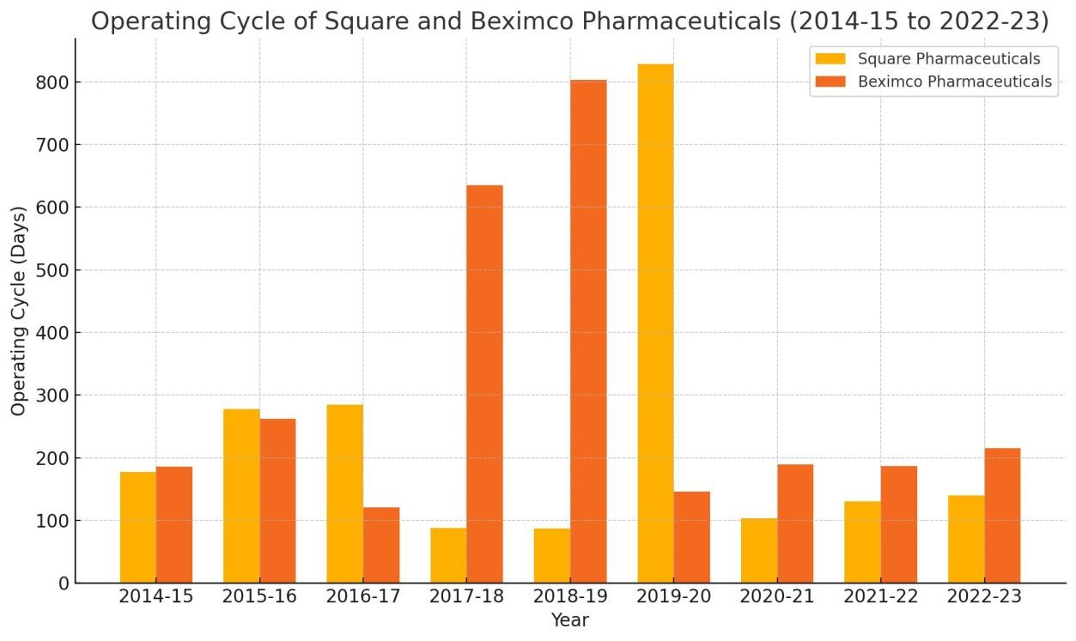

The bar chart compares the operating cycle of Square Pharmaceuticals and Beximco Pharmaceuticals from 2014-15 to 2022-23. Square Pharmaceuticals generally has a longer operating cycle, peaking at around 800 days in 2018-19, which indicates inefficiencies in managing its inventory or receivables. Beximco Pharmaceuticals shows a more stable operating cycle, with some fluctuations but never reaching the extreme levels seen by Square, indicating more efficient operations overall. The shorter operating cycles in the last few years for both companies reflect improvements in operational efficiency, which is a positive trend. However, Square Pharmaceuticals needs to work more on consistency, as its operating cycle shows greater volatility compared to Beximco Pharmaceuticals.

### 2. Current Ratio: (Current Asset/Current Liability)

The current ratio is a liquidity ratio that measures a company's ability to pay short-term and long-term obligations. To gauge this ability, the current ratio considers the current total assets of a company (both liquid and illiquid) relative to that company’s current total liabilities.

|  |  |  |  |  |  |  |
| --- | --- | --- | --- | --- | --- | --- |
| **Comp**  **any** | **Square Pharmaceuticals** | | | **Beximco Pharmaceuticals** | | |
| **Year** | **Current assets** | **Current**  **Liabilities** | **Current Ratio** | **Current assets** | **Current**  **Liabilities** | **Current Ratio** |
| **2022-**  **23** | **70,487,11 6,554** | **4,229,145,7 16** | **16.67** | **20,875,85 4,240** | **13,265,024, 036** | **1.574** |
| **2021-**  **22** | **62347727 888** | **3661828783** | **17.03** | **18419258 282** | **1273593207**  **6** | **1.44** |
| **2020-**  **21** | **55,076,37 9,705** | **3,178,558,9 26** | **17.33** | **13,770,84 6,179** | **9,349,678,4 08** | **1.47** |
| **2019-**  **20** | **47,384,30 3,113** | **3,241,547,7 86** | **14.61** | **57,579,24 2,592** | **41,624,069, 590** | **1.38** |
| **2018-**  **19** | **38,411,64 2,036** | **2,971,088,5**  **29** | **12.93** | **87,210,87**  **8,187** | **30,907,321, 669** | **2.82** |
| **2017-**  **18** | **28441536 241** | **2,200,400,4 92** | **12.93** | **81,275,92 3,350** | **16,235,328, 639** | **5.01** |
| **2016-**  **17** | **5,340,902, 540** | **2,612,186,5 53** | **2.04** | **1,913,858, 151** | **1,193,376,7 11** | **1.60** |
| **2015-**  **16** | **1,164,835, 656** | **1,661,933,1 93** | **0.7** | **889,046,9 24** | **1,579,247,4 73** | **0.6** |
| **2014-**  **15** | **54,487,11 6,455** | **3, 229,145,716** | **12.1** | **29,000,52 5,961** | **4,707,747,4 30** | **6.1** |

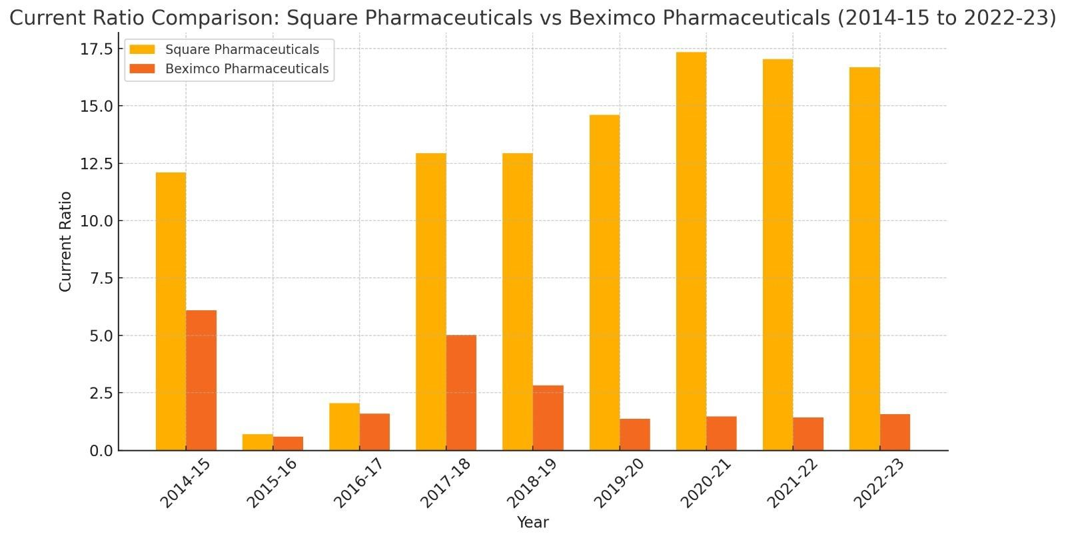

The table and graph compare the current ratios of Square Pharmaceuticals and Beximco Pharmaceuticals from 2014-15 to 2022-23. Square Pharmaceuticals shows fluctuations in its current ratio, starting high at 6.1 in 2014-15, dropping drastically to 0.6 in 2015-16, and then recovering significantly to 5.01 in 2017-18. The graph indicates that Square Pharmaceuticals consistently outperformed Beximco in terms of liquidity for most of the years, especially post-2018. On the other hand, Beximco's current ratio was relatively stable but much lower, ranging between 1 and 2 across most years. A higher current ratio indicates better short-term financial health, meaning Square Pharmaceuticals generally had better liquidity, although its initial decline in 2015-16 could have been a concern. Beximco's lower and stable current ratio suggests a more controlled but weaker liquidity position throughout the period. Overall, Square’s recovery after 2015-16 is positive, while Beximco’s lower ratios may suggest a need for improvement in liquidity management.

#### 3. Quick Ratio: (Current Assets – Inventories)/Current Liabilities

The quick ratio is an indicator of a company's short-term liquidity, and measures a company's ability to meet its short-term obligations with its most liquid assets.

|  |  |  |  |  |  |  |  |  |
| --- | --- | --- | --- | --- | --- | --- | --- | --- |
| **Co mpa**  **ny** | **Square Pharmaceuticals** | | | | **Beximco Pharmaceuticals** | | | |
| **Year** | **Curre nt assets** | **Invent ories** | **Curre nt**  **Liabili ties** | **Quick Ratio** | **Curre nt assets** | **Invent ories** | **Curre nt**  **Liabili ties** | **Quick Ratio** |
| **202**  **2-23** | **70,487,**  **116,55 4** | **12,227,1 98,105** | **4,229,14 5,716** | **13.78** | **20,875,**  **854,24 0** | **12,133,2 77,975** | **13,265,0 24,036** | **0.66** |
| **202**  **1-22** | **623477 27888** | **8214111 144** | **3661828 783** | **14.78** | **184192 8282** | **1040529 5079** | **1273593 2076** | **0.63** |
| **202**  **0-21** | **55,076,**  **379,70 5** | **7,245,39 6,928** | **3,178,55 8,926** | **15.05** | **13,770,**  **846,17 9** | **7,142,86 3,477** | **9,349,67 8,408** | **0.71** |
| **201**  **9-20** | **47,384,**  **303,11 3** | **5,141,95 9,501** | **3,241,54 7,786** | **13.03** | **57,579,**  **242,59 0** | **5,025,07 8,849** | **41,624,0 69,590** | **1.26** |
| **201**  **8-19** | **38,411,**  **642,03 6** | **4,596,51**  **2,673** | **2,971,08 8,529** | **11.38** | **87,210,**  **878,18 7** | **2,782,48 2,251** | **30,907,3**  **21,669** | **2.73** |
| **201**  **7-18** | **284415 36241** | **4,432,93 5,118** | **2,200,40 0,492** | **10.91** | **81,275,**  **923,35 0** | **2,661,66 8,592** | **16,235,3 28,639** | **4.84** |
| **201**  **6-17** | **5,340,9**  **02,540** | **1,963,90 4,495** | **2,612,18 6,553** | **1.29** | **1,913,8**  **58,151** | **968,232,**  **483** | **1,193,37 6,711** | **0.79** |
| **201**  **5-16** | **1,164,8**  **35,656** | **933,216, 132** | **1,661,93 3,193** | **0.14** | **889,04 6,924** | **612,324,**  **290** | **1,579,24 7,473** | **0.17** |
| **201**  **4-15** | **54,487,**  **116,45 5** | **2288698 36** | **3,**  **229,145,**  **716** | **8.2** | **29,000,**  **525,96 1** | **6047172 447** | **4,707,74 7,430** | **5.8** |

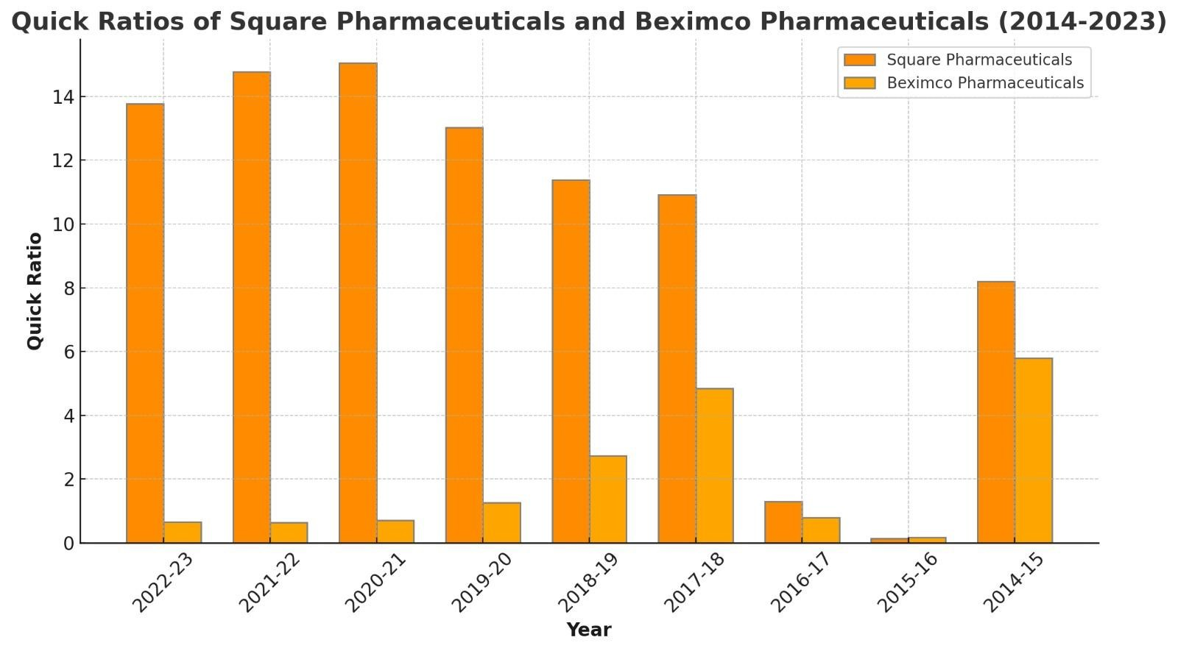

The bar chart shows the quick ratios of Square Pharmaceuticals and Beximco Pharmaceuticals over the period 2014-2023. The quick ratio is a measure of a company’s ability to meet its short-term liabilities with its most liquid assets. For Square Pharmaceuticals, the quick ratios have consistently stayed higher than those of Beximco, showing a strong liquidity position. Square’s ratio peaked in 2021-22, reaching above 14, but has seen a decline by 2022-23, though it still remains robust at around 10. On the other hand, Beximco Pharmaceuticals has had much lower quick ratios throughout, with slight improvements in certain years, like 2018-19 and 2021-22, but generally reflecting a weaker liquidity position compared to Square. Overall, Square has maintained a strong and favorable position, while Beximco has struggled, which could indicate potential issues with its shortterm financial health.

#### 4. Cash Ratio: (Cash/Current Liabilities)

The cash ratio or cash coverage ratio is a liquidity ratio that measures a firm's ability to pay off its current liabilities with only cash and cash equivalents.

|  |  |  |  |  |  |  |
| --- | --- | --- | --- | --- | --- | --- |
| **Comp**  **any** | **Square Pharmaceuticals** | | | **Beximco Pharmaceuticals** | | |
| **Year** | **Cash** | **Current**  **Liabilities** | **Cash Ratio** | **Cash** | **Current**  **Liabilities** | **Cash Ratio** |
| **2022-**  **23** | **50,094,32 1,854** | **4,229,145,7 16** | **11.85** | **1,135,686, 178** | **13,265,024, 036** | **0.086** |
| **2021-**  **22** | **48962498 336** | **3661828783** | **13.37** | **11686738 21** | **1273593207**  **6** | **0.091** |
| **2020-**  **21** | **43,364,03 9,004** | **3,178,558,9 26** | **13.64** | **675,466,6 08** | **9,349,678,4 08** | **.0722** |
| **2019-**  **20** | **32,564,32 9,438** | **3,241,547,7 86** | **10.05** | **29,90,94,2 55** | **41,624,069, 590** | **0.0071** |
| **2018-**  **19** | **27,004,03 8,946** | **2,971,088,5**  **29** | **9.08** | **350,416,0 34** | **30,907,321, 669** | **0.01** |
| **2017-**  **18** | **16,980,41 2,765** | **2,200,400,4 92** | **7.72** | **67,524,82 9** | **16,235,328, 639** | **4.16** |
| **2016-**  **17** | **862,921,7 63** | **2,612,186,5 53** | **0.33** | **3,478,299** | **1,193,376,7 11** | **2.91** |
| **2015-**  **16** | **111,682,9 87** | **1,661,933,1 93** | **0.07** | **16,295,22 3** | **1,579,247,4 73** | **2.87** |
| **2014-**  **15** | **50,487,11 6,554** | **3, 229,145,716** | **16.67** | **222,239,2 39** | **4,707,747,4 30** | **8.4** |

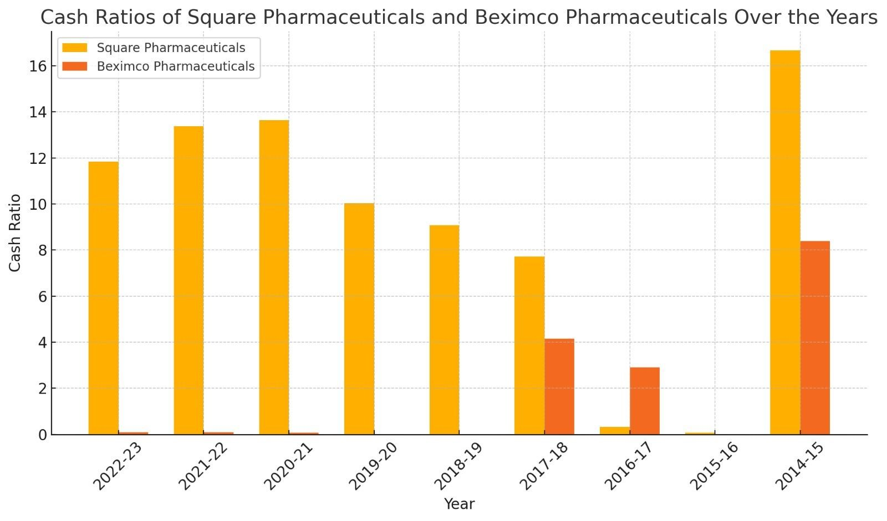

The chart compares the cash ratios of Square Pharmaceuticals and Beximco Pharmaceuticals from 2014-15 to 2022-23. Square Pharmaceuticals consistently shows significantly higher cash ratios, peaking in 2016-17 and maintaining strong performance throughout the period. In contrast, Beximco Pharmaceuticals has much lower cash ratios, close to zero in 2017-18 and earlier, though it has a noticeable improvement from 2019-20 onwards, peaking in 2022-23. Overall, Square Pharmaceuticals appears to maintain better liquidity throughout the period, indicating stronger financial health compared to Beximco, which showed some improvement but remains significantly behind. The cash ratio disparity suggests that Beximco Pharmaceuticals has historically struggled with liquidity, but its recent improvement is a positive sign.

**5. Cash Conversion Cycle: (Average Collection Period +**

## Inventory Conversion Period) – Payment Deferral Period

The cash conversion cycle is a metric used to gauge the effectiveness of a company's management and, consequently, the overall health of that company. The calculation measures how fast a company can convert cash on hand into inventory and accounts payable, through sales and accounts receivable, and then back into cash.

|  |  |  |  |  |  |  |  |  |
| --- | --- | --- | --- | --- | --- | --- | --- | --- |
| **Co mpa**  **ny** | **Square Pharmaceuticals** | | | | **Beximco Pharmaceuticals** | | | |
| **Year** | **Avera ge**  **collect ion**  **perio d** | **Invent ory**  **conver sion period** | **Payme nt**  **deferr al period** | **Cash conver sion cycle** | **Avera ge**  **collect ion**  **perio d** | **Invent ory**  **conver sion period** | **Payme nt**  **deferr al period** | **Cash conver sion cycle** |
| **202**  **2-23** | **24.523** | **115.807** | **11.51** | **128** | **30.793** | **184.795** | **58.72** | **156** |
| **202**  **1-22** | **19.73** | **99.45** | **8.30** | **110** | **31.25** | **167.52** | **47.72** | **151** |
| **202**  **0-21** | **10** | **94** | **9** | **95** | **38** | **152** | **46** | **144** |
| **201**  **9-20** | **10.62** | **818.18** | **50.90** | **77** | **16.00** | **130.43** | **61.55** | **84** |
| **201**  **8-19** | **11.21** | **75.88** | **11.68** | **75** | **744.90** | **58.78** | **206.09** | **97** |
| **201**  **7-18** | **14.98** | **73.17** | **9.40** | **78** | **521.74** | **113.56** | **175.93** | **357** |
| **201**  **6-17** | **82.94** | **191.49** | **6.13** | **268** | **89.33** | **31.80** | **0.22** | **120** |
| **201**  **5-16** | **53.7** | **225** | **2.6** | **276** | **124.13** | **138.46** | **153.9** | **108** |
| **201**  **4-15** | **30.12** | **145.74** | **10.51** | **165** | **40.67** | **147.54** | **54.65** | **133** |

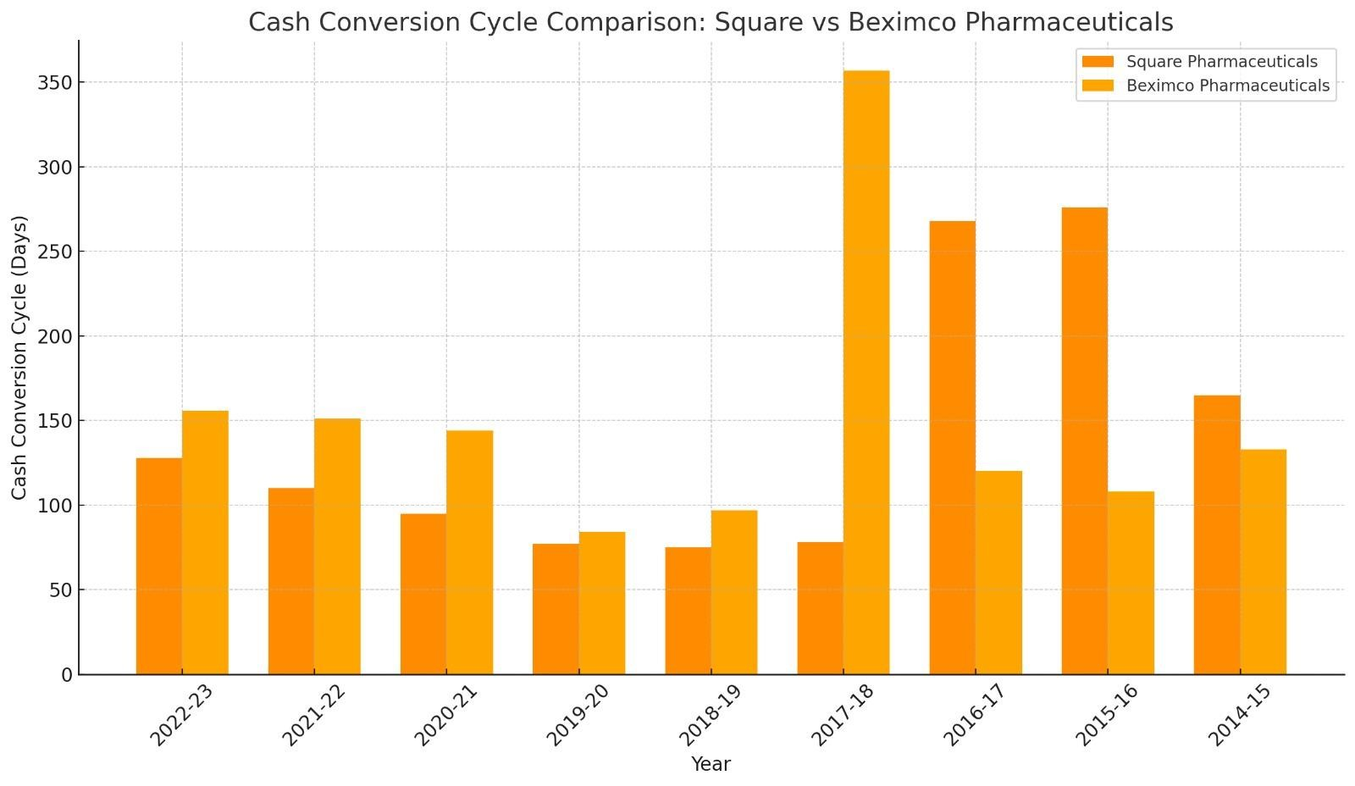

The graph compares the Cash Conversion Cycle (CCC) of Square Pharmaceuticals and Beximco Pharmaceuticals over several fiscal years from 2014-15 to 2022-23. In 2014-15, Beximco had a CCC of around 200 days, while Square was slightly below 150 days. Over the years, Square’s CCC remained relatively consistent, fluctuating between 50 and 150 days. Beximco, on the other hand, saw major fluctuations with a peak in 2017-18, where its CCC spiked dramatically to around 350 days. In more recent years (2021-23), the CCC for both companies has stabilized, with Square maintaining a lower CCC of around 100 days, while

Beximco remains slightly higher. Generally, Square’s more stable and lower CCC is a positive sign of operational efficiency, whereas Beximco’s higher and more volatile CCC, particularly the spike in 2017-18, indicates less efficiency, which can be seen as a negative.

**6. Comprehensive Liquidity Index: (Adjusted Current**

## Asset/Adjusted Current Liability)

The liquidity index calculates the days required to convert a company's trade receivables and inventory into cash. The index is used to estimate the ability of a business to generate the cash needed to meet current liabilities.

|  |  |  |  |  |  |  |
| --- | --- | --- | --- | --- | --- | --- |
| **Comp**  **any** | **Square Pharmaceuticals** | | | **Beximco Pharmaceuticals** | | |
| **Year** | **Adjuste d**  **Current**  **Asset** | **Adjusted current liability** | **Compreh**  **ensive liquidity index** | **Adjuste d**  **Current**  **Asset** | **Adjusted current liability** | **Compreh**  **ensive liquidity index** |
| **2022-**  **23** | **6,443.814, 050** | **4,229,145,7 16** | **1.52** | **4,875,116, 321** | **3,978,524,1 34** | **1.23** |
| **2021-**  **22** | **57666478 37** | **6220190674** | **2.7** | **86784472 57** | **2206378229** | **3.93** |
| **2020-**  **21** | **25,860,07 4,350** | **9,897,674,8 70** | **2.61** | **6,340,004, 780** | **1,236,873,8 90** | **5.13** |
| **2019-**  **20** | **26636220 19** | **540805809** | **4.25** | **32112020 11** | **3729859454** | **1.86** |
| **2018-**  **19** | **32,157,87 8,786** | **693,829,701** | **6.35** | **54,414,02 0,461** | **4,272,104,2 89** | **2.74** |
| **2017-**  **18** | **22834263 22** | **8504264151** | **3.7** | **2,761,509, 39** | **1,397,498,6 4** | **1.75** |
| **2016-**  **17** | **17176822 33** | **1700515116** | **1.01** | **79072550**  **7** | **132290709** | **5.98** |
| **2015-**  **16** | **46336662**  **2.4** | **11,084,551. 728** | **4.8** | **45860332**  **4** | **456136452** | **1.005** |
| **2014-**  **15** | **1,417,682, 200** | **1,387,562,2 33** | **1.02** | **1,117,682, 600** | **1,087,562,7 50** | **1.05** |

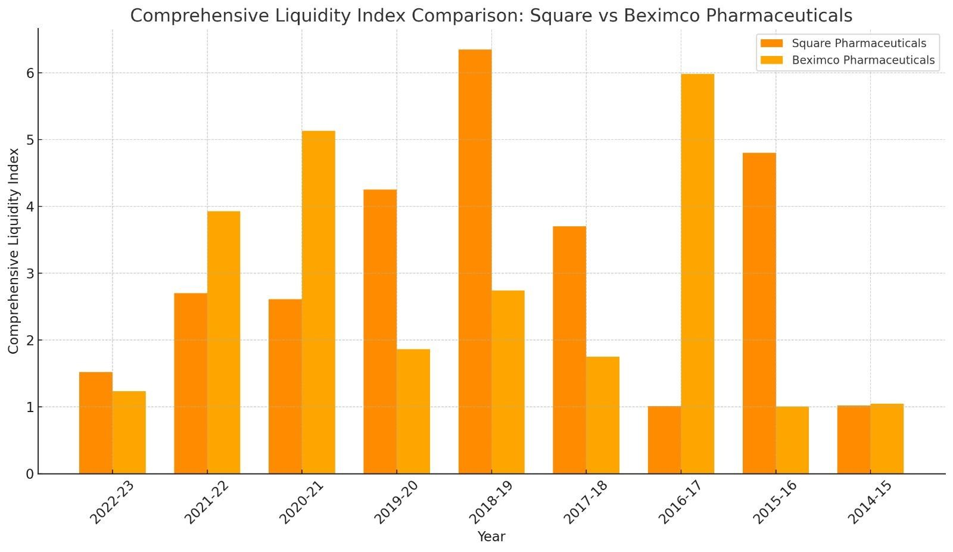

The bar chart compares the Comprehensive Liquidity Index between Square Pharmaceuticals and Beximco Pharmaceuticals from 2014 to 2022. Throughout the years, Square Pharmaceuticals generally shows higher liquidity than Beximco, particularly in 2021 and 2016, where the gap is most significant. Beximco, on the other hand, exhibits more fluctuation with peaks in 2017 and 2021. Both companies experienced a noticeable decline in liquidity around 2019. In terms of performance, Square's consistently higher liquidity is favorable as it suggests a better ability to meet short-term obligations, while Beximco's more inconsistent performance may raise concerns about its financial flexibility in certain years.

**7. Net Liquid Balance: (Cash + Marketable Securities – Notes**

## Payable)/Total Asset

Net liquid assets are a strict measure of an immediate or near-term liquidity position of a firm.

|  |  |  |  |  |  |  |
| --- | --- | --- | --- | --- | --- | --- |
| **Comp**  **any** | **Square Pharmaceuticals** | | | **Beximco Pharmaceuticals** | | |
| **Year** | **Cash** | **Total asset** | **Net liquid balance ratio** | **Cash** | **Total asset** | **Net liquid balance ratio** |
| **2022-**  **23** | **50,094,32 1,854** | **121,816,305 ,166** | **0.4112** | **1,135,686, 178** | **69,156,783, 247** | **0.016** |
| **2021-**  **22** | **48962498 336** | **1099887287 17** | **0.45** | **11686738 21** | **6614803574**  **2** | **0.017** |
| **2020-**  **21** | **43,364,03 9,004** | **86,602,383, 695** | **0.50** | **675,466,6 08** | **52,246,084, 026** | **0.0129** |
| **2019-**  **20** | **32,564,32 9,438** | **8182014172**  **0** | **0.40** | **29,90,94,2 55** | **1311435314 88** | **0.0022** |
| **2018-**  **19** | **27,004,03 8,946** | **72,146,052, 574** | **0.37** | **350,416,0 34** | **128,453,030 ,539** | **0.003** |
| **2017-**  **18** | **16,980,41 2,765** | **6127300153**  **5** | **0.28** | **67,524,82 9** | **1227463016 64** | **0.50** |
| **2016-**  **17** | **862,921,7 63** | **10,182,157, 362** | **0.08** | **3,478,299** | **3,241,016,0 42** | **0.001** |
| **2015-**  **16** | **111,682,9 87** | **1,164,835,6 56** | **0.086** | **16,295,22 3** | **889,046,924** | **0.18** |
| **2014-**  **15** | **50,487,11 6,554** | **112,816,305 ,177** | **0.35** | **222,239,2 39** | **29,000,525, 961** | **0.77** |

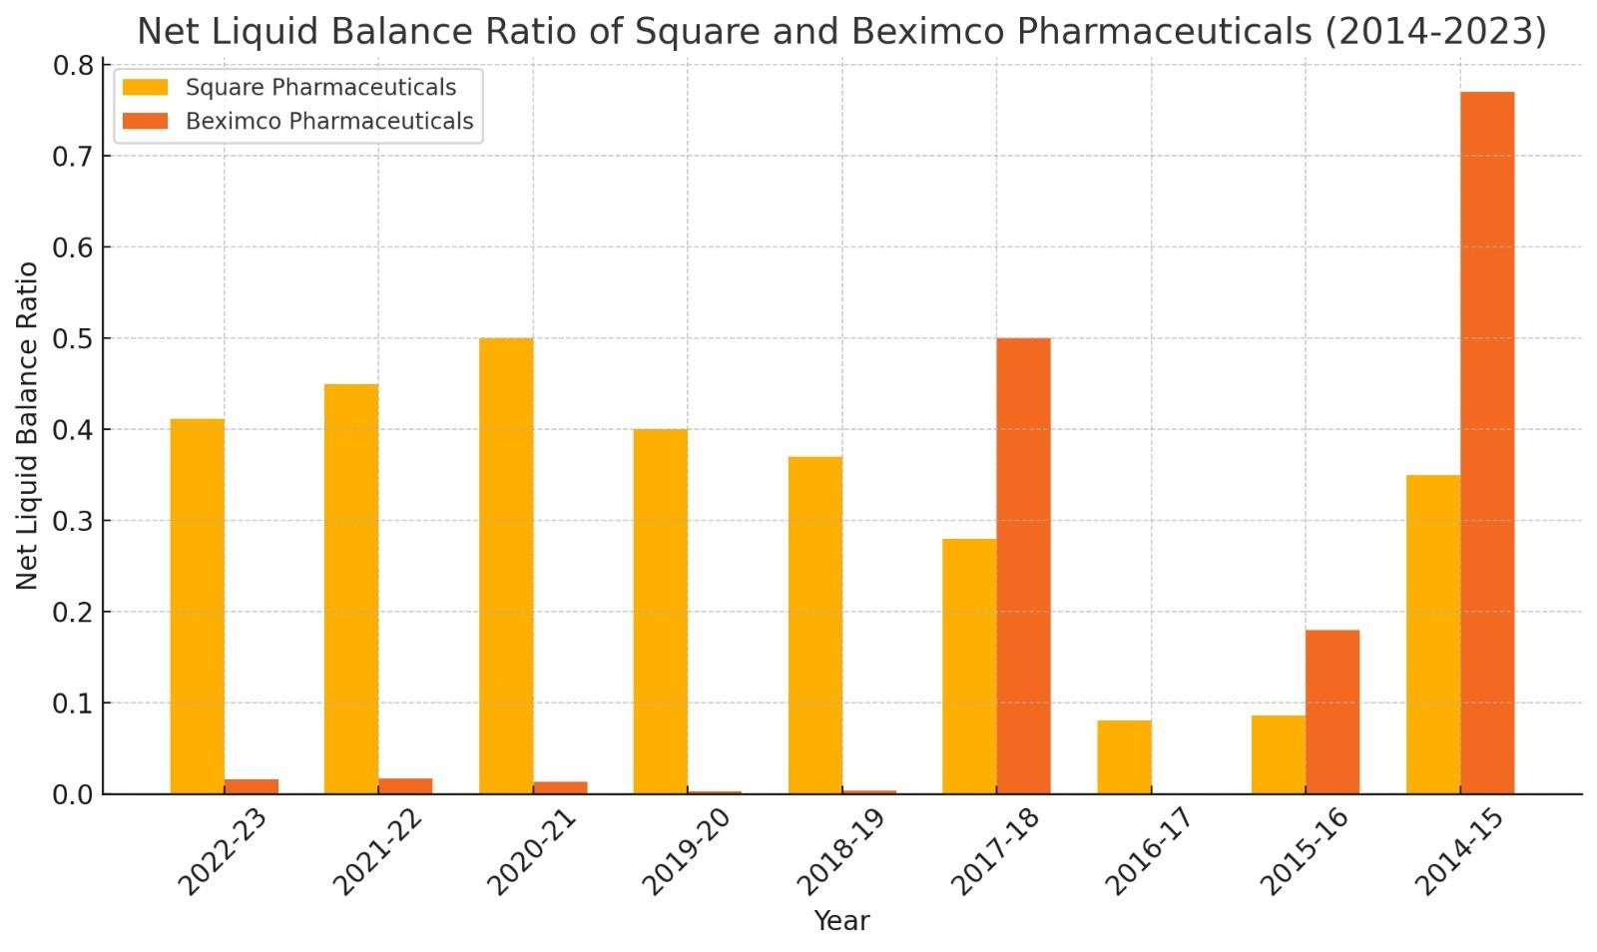

The chart compares the Net Liquid Balance Ratio of Square Pharmaceuticals and Beximco Pharmaceuticals from 2014 to 2023. Square Pharmaceuticals consistently outperforms Beximco, particularly in the 2014-15 and 2017-18 periods, where Square has a significantly higher ratio. The trend for both companies fluctuates over the years, with Square generally maintaining a higher balance ratio, except for a steep drop in 2017-18. Beximco shows a steady low ratio, particularly in recent years (2020-23). The higher ratios, especially for

Square, suggest stronger liquidity and financial stability compared to Beximco, making Square's performance comparatively better.

**(C) Profitability Ratios:**

Profitability ratios are financial metrics used by analysts and investors to measured and evaluate the ability of a company to generate income (profit) relative to revenue, balance sheet assets, operating costs, and shareholders’ equity during a specific period of time. They show how well a company utilizes its assets to produce profit and value to shareholders.

A higher ratio or value is commonly sought-after by most companies, as this usually means the business is performing well by generating revenues, profits, and cash flow. The ratios are most useful when they are analyzed in comparison to similar companies or compared to previous periods. Profitability ratios are:

1. Gross Margin Ratio
2. Net Profit Margin Ratio

### 1. Gross Margin Ratio: ( Gross profit / Sales)

Gross margin ratio is a profitability ratio that compress the gross margin of a business to the net sales. This ratio measures how profitable a company sells its inventory or merchandise. In other words, the gross profit ratio is essentially the percentage markup on merchandise from its cost.

|  |  |  |  |  |  |  |
| --- | --- | --- | --- | --- | --- | --- |
| **Comp**  **any** | **Square Pharmaceuticals** | | | **Beximco Pharmaceuticals** | | |
| **Year** | **Gross profit** | **Sales** | **Gross margin ratio** | **Gross profit** | **Sales** | **Gross margin ratio** |
| **2022-**  **23** | **30,975,58 9,564** | **72,335,373, 485** | **0.43** | **17,313,37 1,771** | **39,266,662, 237** | **0.441** |
| **2021-**  **22** | **29639914 379** | **5759794135**  **9** | **0.51** | **15814252 319** | **3466917205**  **2** | **0.017** |
| **2020-**  **21** | **25,902,99 3,347** | **58,346,258, 281** | **0.443** | **13,923,50 2,288** | **29,493,573, 869** | **0.46** |
| **2019-**  **20** | **23339778 881** | **5292621865**  **5** | **0.44** | **71445263 56** | **2103568855**  **8** | **0.34** |
| **2018-**  **19** | **21,942,24 9,918** | **50,866,867, 352** | **0.43** | **8,211,116, 174** | **25,485,452, 571** | **0.32** |
| **2017-**  **18** | **19564011 725** | **4588695930**  **3** | **0.4** | **7,962,046, 585** | **9,156,783,2 47** | **0.31** |
| **2016-**  **17** | **525,63400**  **0** | **7,758,879,1 64** | **0.07** | **69,353678** | **2,899,465** | **0.024** |
| **2015-**  **16** | **1,309,032, 879** | **2,841,862,4 73** | **0.05** | **453,345,5 12** | **2,053,499,9 30** | **0.2** |
| **2014-**  **15** | **25,975,50 0,554** | **52,335,373, 485** | **0.4** | **5,104,191, 354** | **11,206,885, 677** | **0.45** |

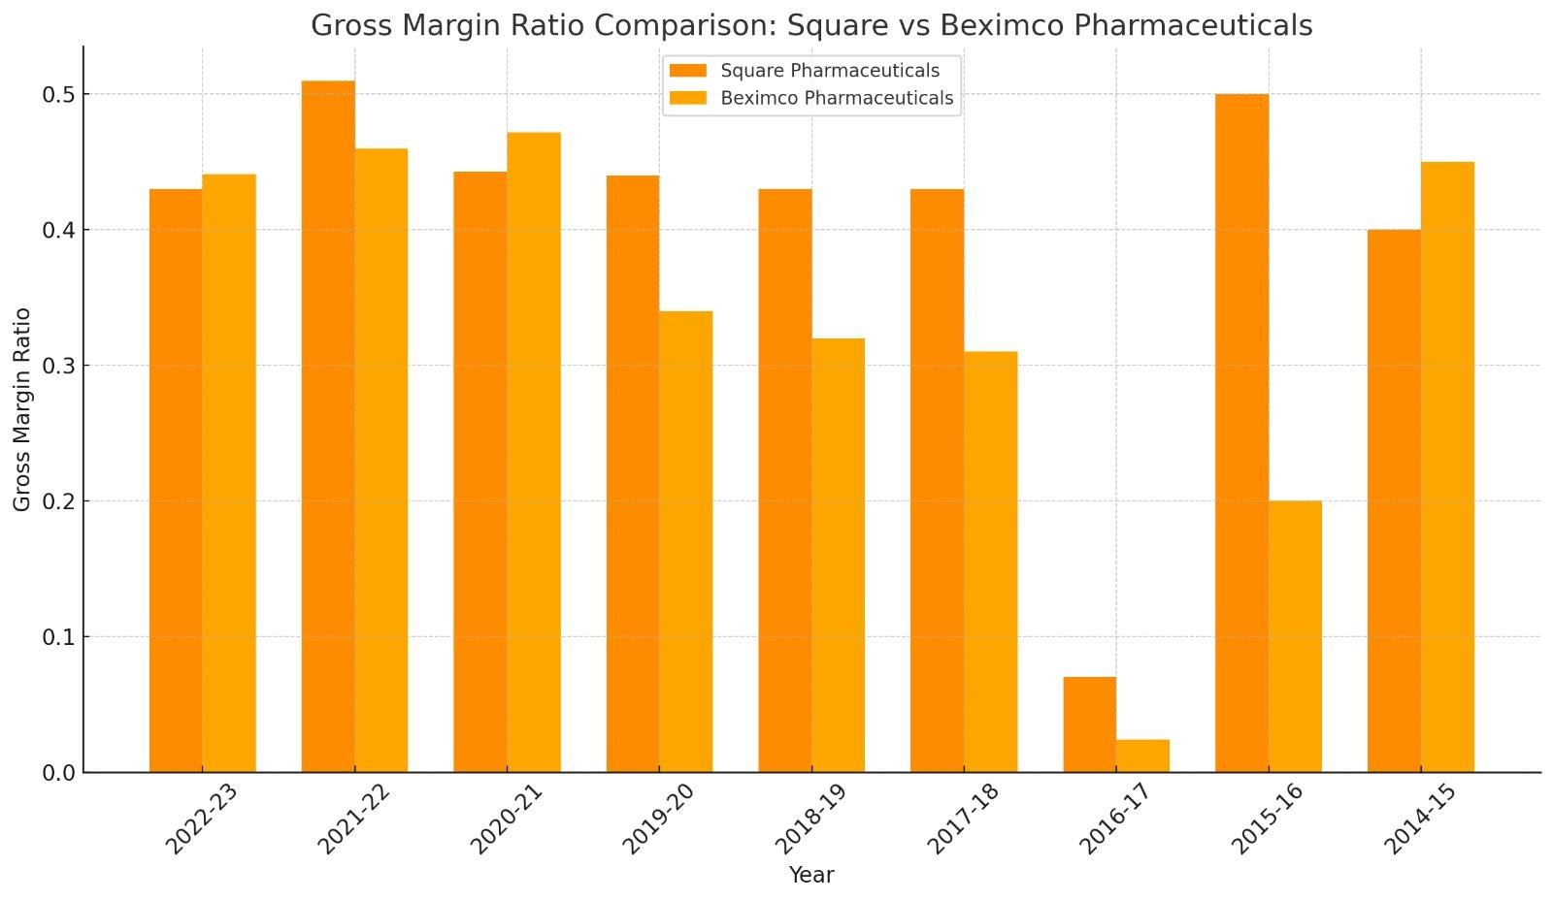

The image presents a comparison of the gross margin ratios between Square Pharmaceuticals and Beximco Pharmaceuticals across several fiscal years, as represented in the bar chart. Square consistently shows higher gross margin ratios across most years, especially in recent periods such as 2022-23 and 2021-22, where its margin is approximately 0.45 and 0.42, respectively. Beximco shows significantly lower margins in earlier years, such as 2016-17 and 2017-18, with a recovery only in recent years, reaching about 0.3 to 0.4 in 2022-23. Overall, Square performs better in terms of gross margin, maintaining more stability, while Beximco has improved but still lags behind. Square's performance appears stronger and more consistent, while Beximco shows gradual improvement, but historically lower margins are a point of concern for the latter.

**2.Net Profit Margin Ratio: (Net profit before tax / Revenue)**

The net profit margins measures the percentage of each sales dollar remaining after all costs and expenses, including interest, taxes, and preferred stock dividends, have been deducted. The higher the firm’s net profit margin, the better.

|  |  |  |  |  |  |  |
| --- | --- | --- | --- | --- | --- | --- |
| **Comp**  **any** | **Square Pharmaceuticals** | | | **Beximco Pharmaceuticals** | | |
| **Year** | **Net profit**  **before tax** | **Revenue** | **Net Profit**  **Margin Ratio** | **Net profit**  **before tax** | **Revenue** | **Net Profit**  **Margin Ratio** |
| **2022-**  **23** | **21,099,3**  **51,200** | **62,747,68**  **2,864** | **0.34** | **6,068,76**  **8,942** | **39,266,662, 237** | **0.155** |
| **2021-**  **22** | **2077299 5235** | **57597941**  **359** | **0.36** | **6686945**  **001** | **3466917205**  **2** | **0.19** |
| **2020-**  **21** | **6,340,00**  **4,780** | **1,236,873,**  **890** | **0.22** | **6,377,54**  **8,193** | **29,493,573, 869** | **0.21** |
| **2019-**  **20** | **1718538 1957** | **21035688**  **558** | **0.32** | **8063991**  **72** | **52926218 655** | **0.015** |
| **2018-**  **19** | **1566088 7890** | **50,866,867, 352** | **0.31** | **1659433**  **036** | **25,485,452, 571** | **0.07** |
| **2017-**  **18** | **1384793 8760** | **4588695930**  **3** | **0.30** | **1408839**  **273** | **9,156,783,2 47** | **0.055** |
| **2016-**  **17** | **297,5920**  **00** | **7,758,879,1 64** | **0.04** | **226,348** | **407,051** | **0.56** |
| **2015-**  **16** | **72,505,9**  **43** | **2,841,862,4 73** | **0.025** | **60,744,9**  **18** | **2,053,499,9 30** | **0.029** |
| **2014-**  **15** | **16,800,3**  **51400** | **42,747,68**  **2,550** | **0.39** | **2,109,55**  **5,733** | **1,529,297,**  **573** | **1.37** |

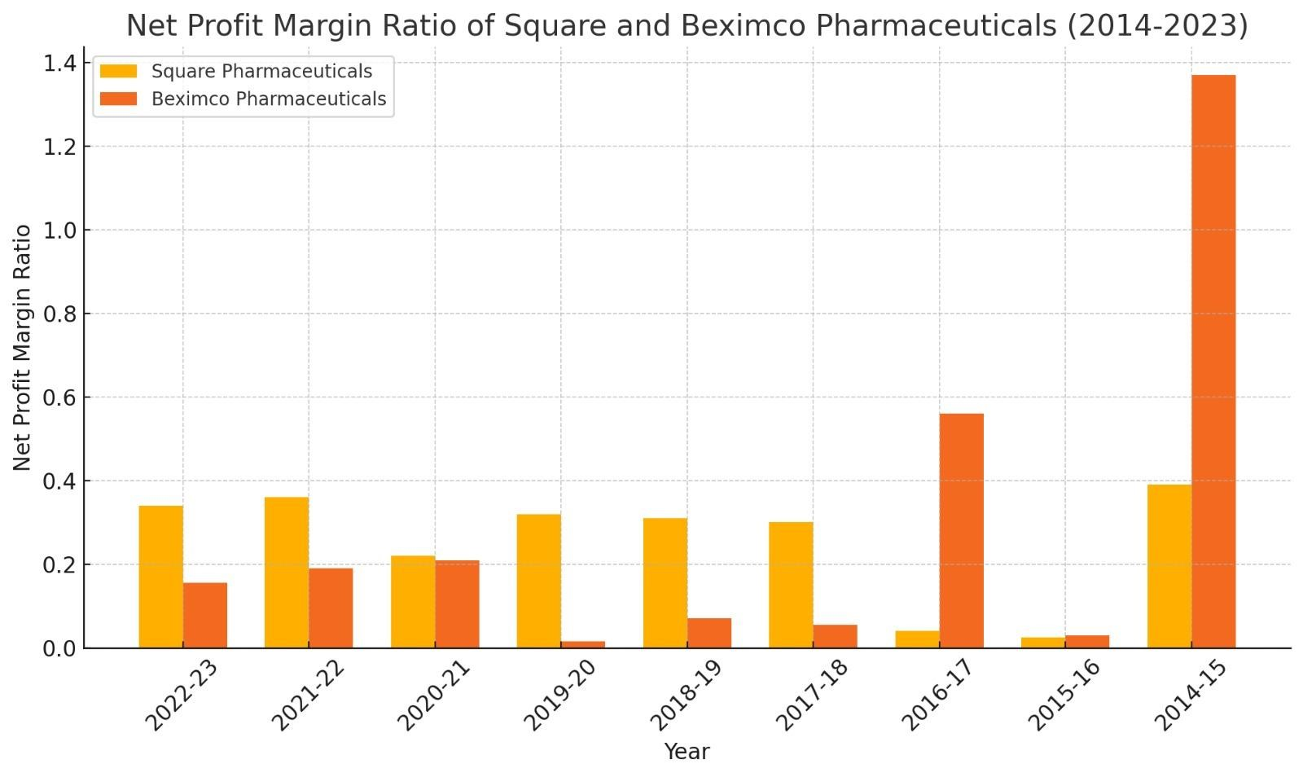

The bar chart compares the Net Profit Margin Ratio of Square Pharmaceuticals and Beximco Pharmaceuticals from 2014 to 2023. In the earlier years (2014-2016), Beximco shows a notably higher profit margin, particularly in 2014-15, where the margin exceeds 1.2. However, from 2017 onward, the profit margin for both companies tends to stabilize, with both hovering around 0.2 to 0.6. Square Pharmaceuticals maintains a more consistent performance over the years, showing modest but steady growth. Beximco, on the other hand, displays erratic profit margins, with a significant dip in 2017-18, followed by gradual growth. The performance of both companies in the latest years (2021-23) is comparable, suggesting improved competition or recovery. Overall, the chart indicates stability for Square Pharmaceuticals, while Beximco shows more volatility, making Square's performance relatively more reliable. Whether it's "good" or "bad" depends on risk tolerance—Square is stable, and Beximco has the potential for higher peaks but comes with more fluctuations.

# Chapter 5 Recommendations And Conclusion

## 5.1 Recommendation

After analyzing the Beximco & Square Pharmaceutical Ltd.‖ following recommendations can be offered:

* Here the position of square pharmaceutical is very stronger than Beximco.So,this company should be more sincere to increase profitability.
* Companies should improve the efficiency of working capital management. Enough adroit human resources should be employed specially in Beximco pharmaceuticals.
* Both companies should be very careful about their rules and regulations.
* Higher authority should more careful and conscious at the time of setting plan.

## 5.2 Conclusion

Over the past decade, Beximco and Square Pharmaceuticals have demonstrated stark differences in their financial performance, particularly in profitability and working capital management. Beximco has faced challenges with inconsistent profitability, likely due to higher operating costs and inefficient financial strategies. This has been compounded by poor working capital management, where longer collection periods, slow inventory turnover, and difficulties in managing short-term liabilities have strained liquidity and overall financial health. In contrast, Square Pharmaceuticals has maintained strong profitability, driven by effective cost control, strategic market positioning, and investment in R&D. Furthermore, Square has demonstrated excellent working capital management, ensuring efficient inventory turnover, timely collection of receivables, and optimal management of payables, which have contributed to its strong liquidity position. The comparative analysis highlights that Square’s disciplined approach to financial and operational management has fostered sustained growth and stability, while Beximco’s struggles signal the need for improved financial strategies and operational efficiency to enhance its market competitiveness.

**References**

To accomplish this project necessary references have given below:

1. Annual report of Beximco & Square Pharmaceutical Ltd .(2023-2015)
2. <https://beximcopharma.com/>
3. <https://www.squarepharma.com.bd/>
4. [www.wikipedia.org](http://www.wikipedia.org/)
5. Working Capital Management written by Frederick C. Scheer.
6. <https://www.investopedia.com/>
7. <https://www.studocu.com/>
8. <https://openai.com/chatgpt/>
9. <https://gemini.google.com/>